To Create a New Database on Client

Find the SQL DB (.mdf & .ldf) file from the path (D:\webapps\DbFiles) & release it to client database path.

Connect to Microsoft SQL Server

As the Screen displayed Below:
Click on Start Button -> All Programs -> Microsoft SQL Server 2005 -> SQL Server Management Studio Express.

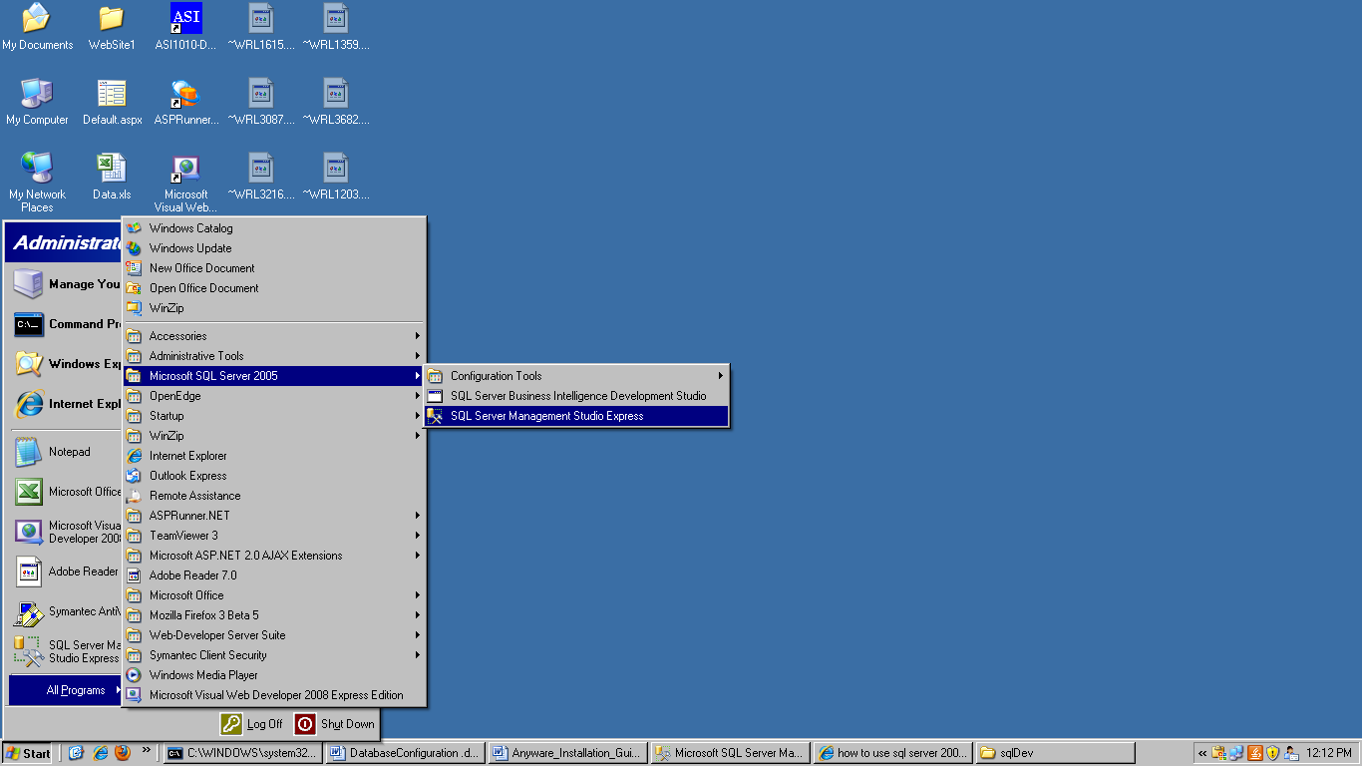

Attach Database to Microsoft SQL Server

- After Connecting SQL Database First screen will be displayed:

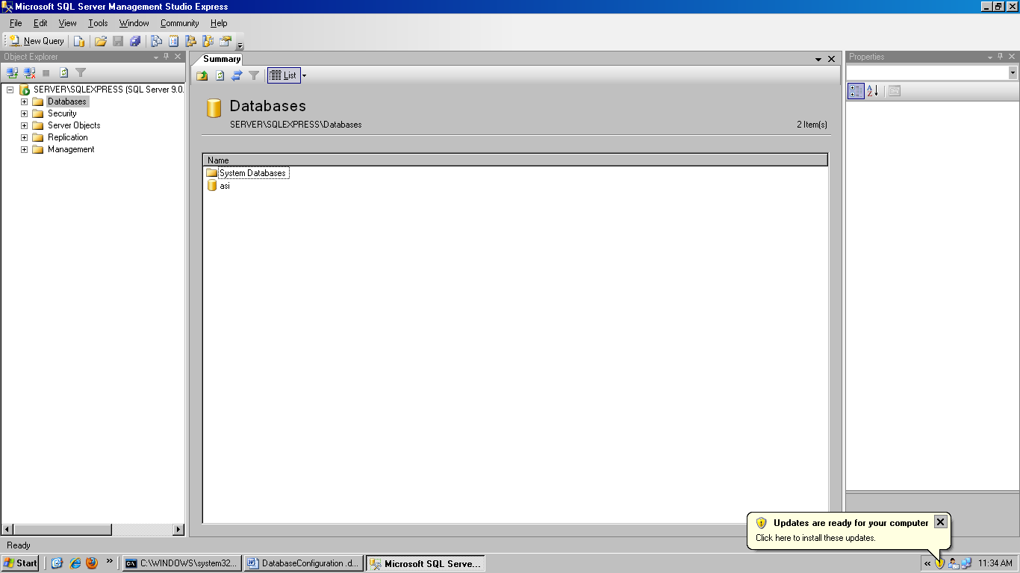

- First, Right Click on Databases & choose Attach Option as the screen displayed Below:

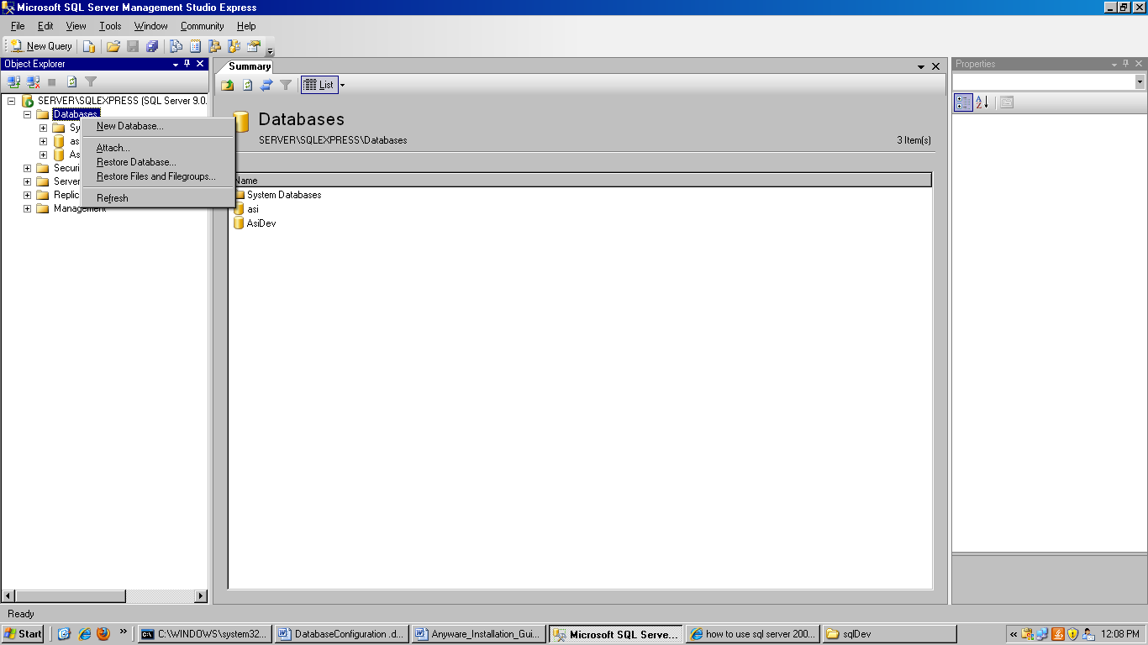

- After Clicking Attach, It will open a sub window & the screen will be displayed as Below:

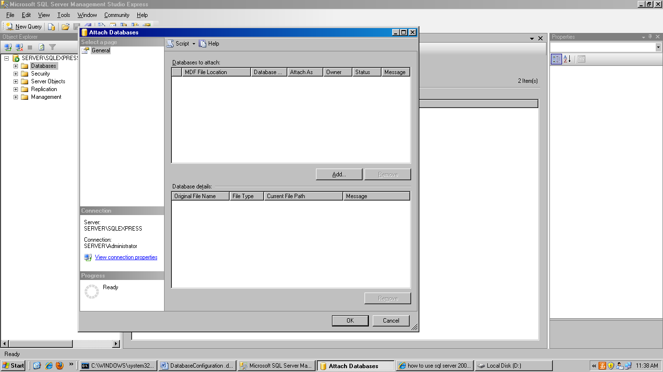

- Click on the Add Button as the screen displayed Below:

Click Add Button

- It will open an another sub window as the screen displayed Below:

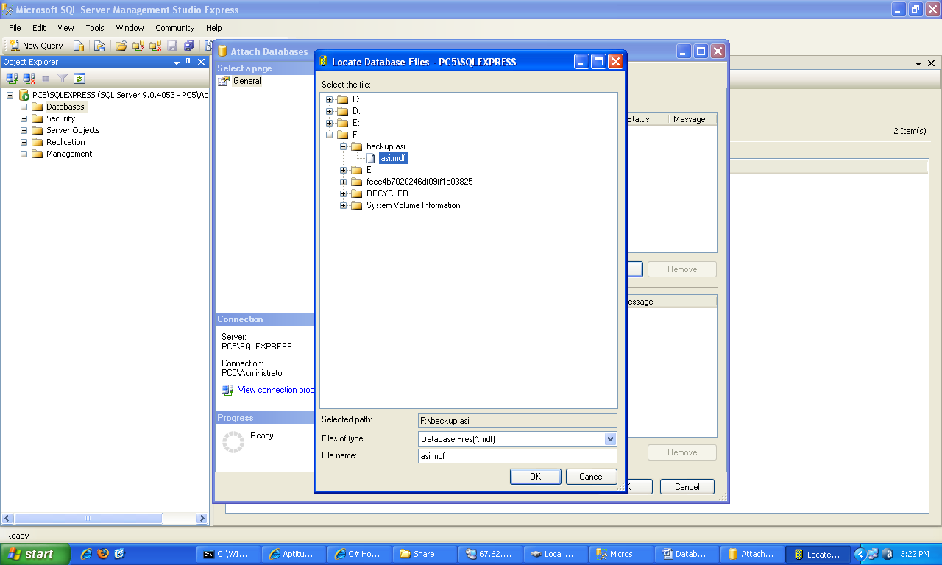

- Choose the path of .mdf file where your (.mdf and .ldf) both files are physically stored.

Choose the Physical Path

- Select the File & Click Ok Button. It will Come to Last Window as the screen displayed Below:

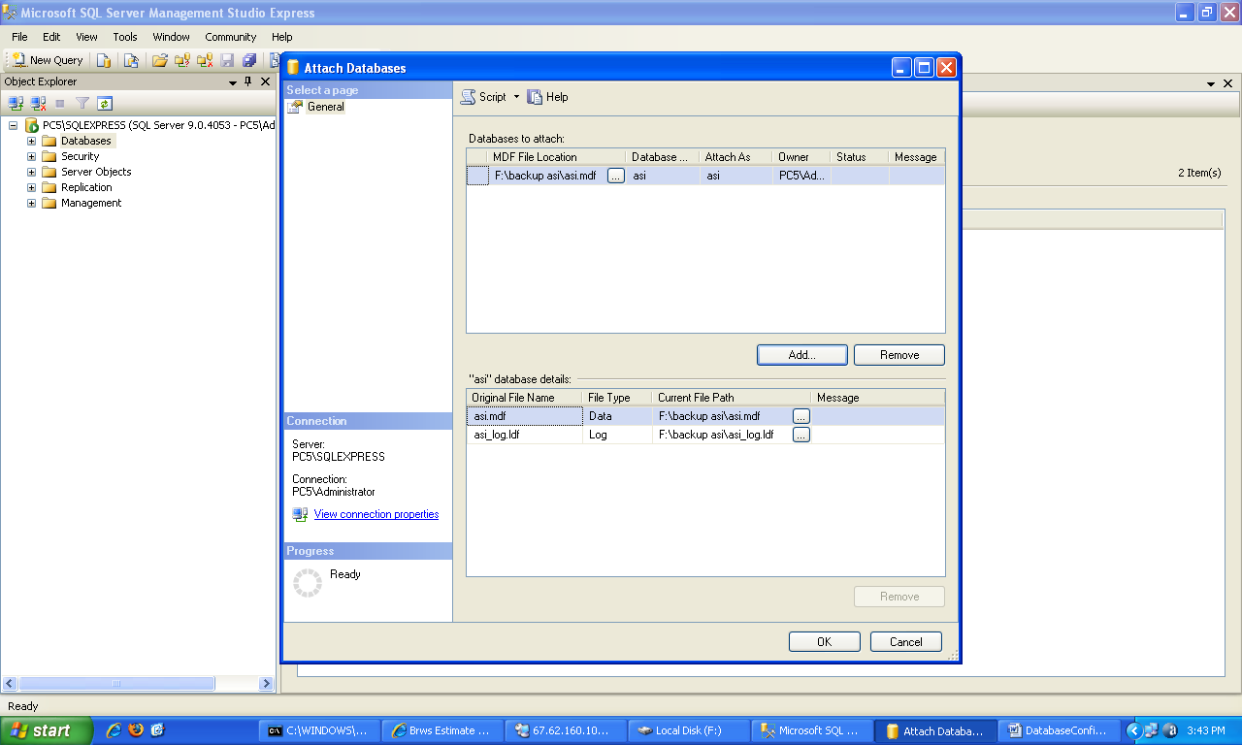

- When you are done with locating, click on OK button. And you are done with things.
- Your SQL Server with Management Studio is ready.

SCHEMA CHANGES IN DATABASE

Add New Table to Database:

- Find the new added .sql file from the path (D:\webapps\DbFiles).
- Open the .sql file in text editor like wordpad & Choose the option Select All as the screen displayed Below:

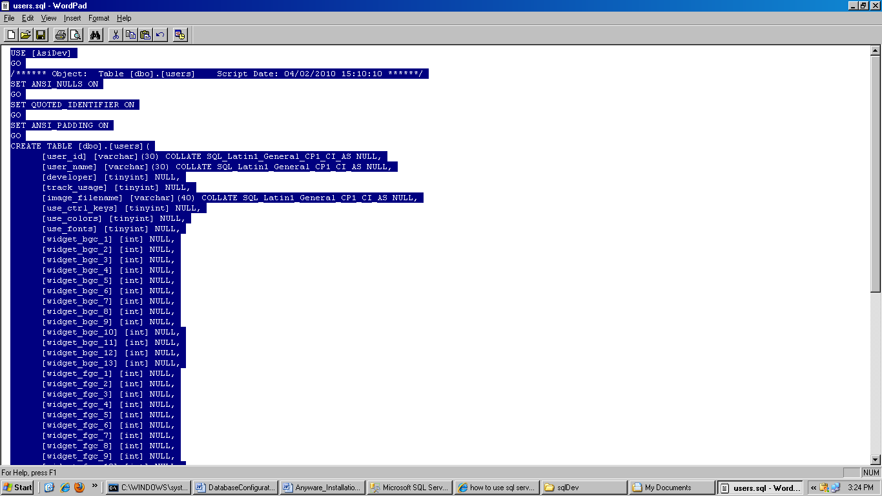

- Choose Edit -> Copy.
- Right Click on Database where you want to insert table & choose New Query Option as the screen displayed Below:

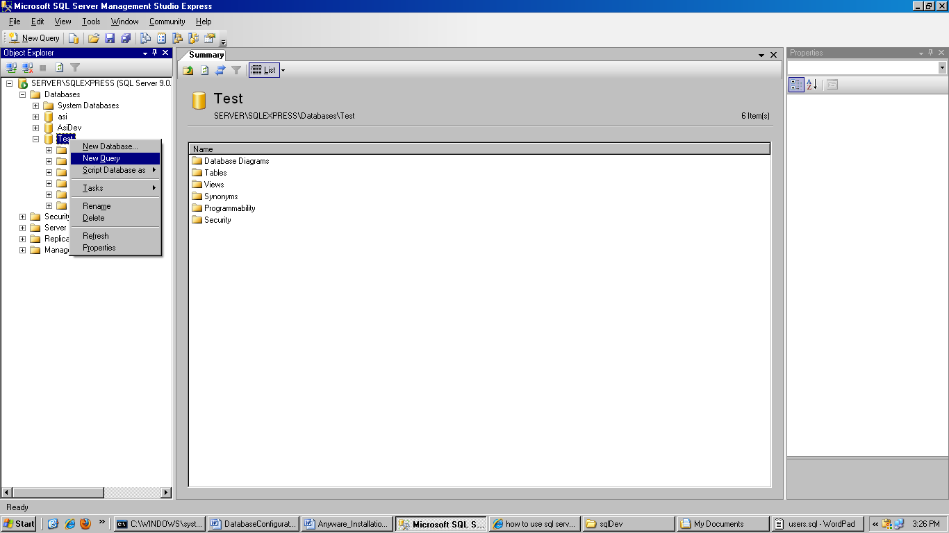
- After choosing New Query option screen will look like this:

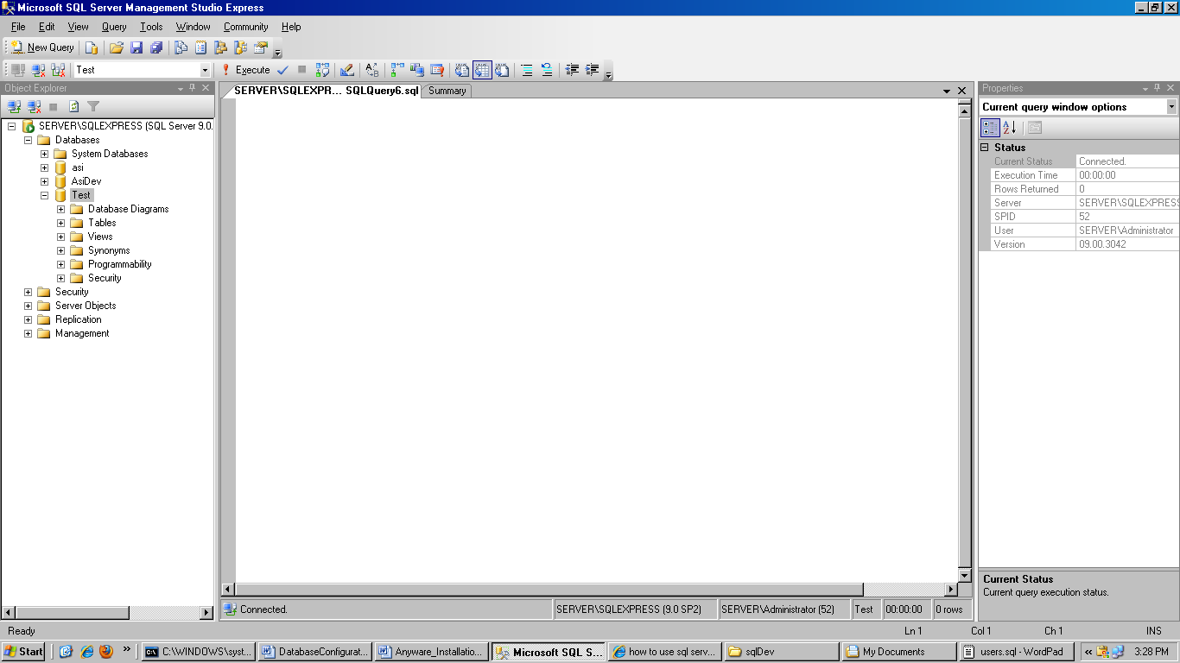

- Paste All the matter in query window as the screen displayed:

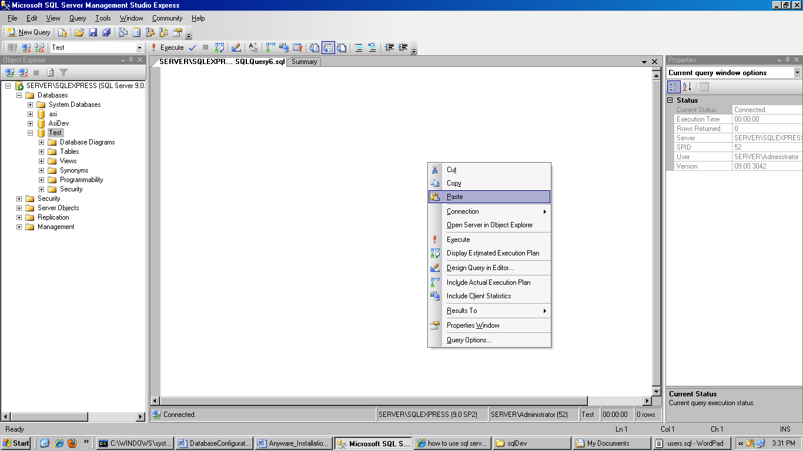

- After Pasting the screen will look like this:

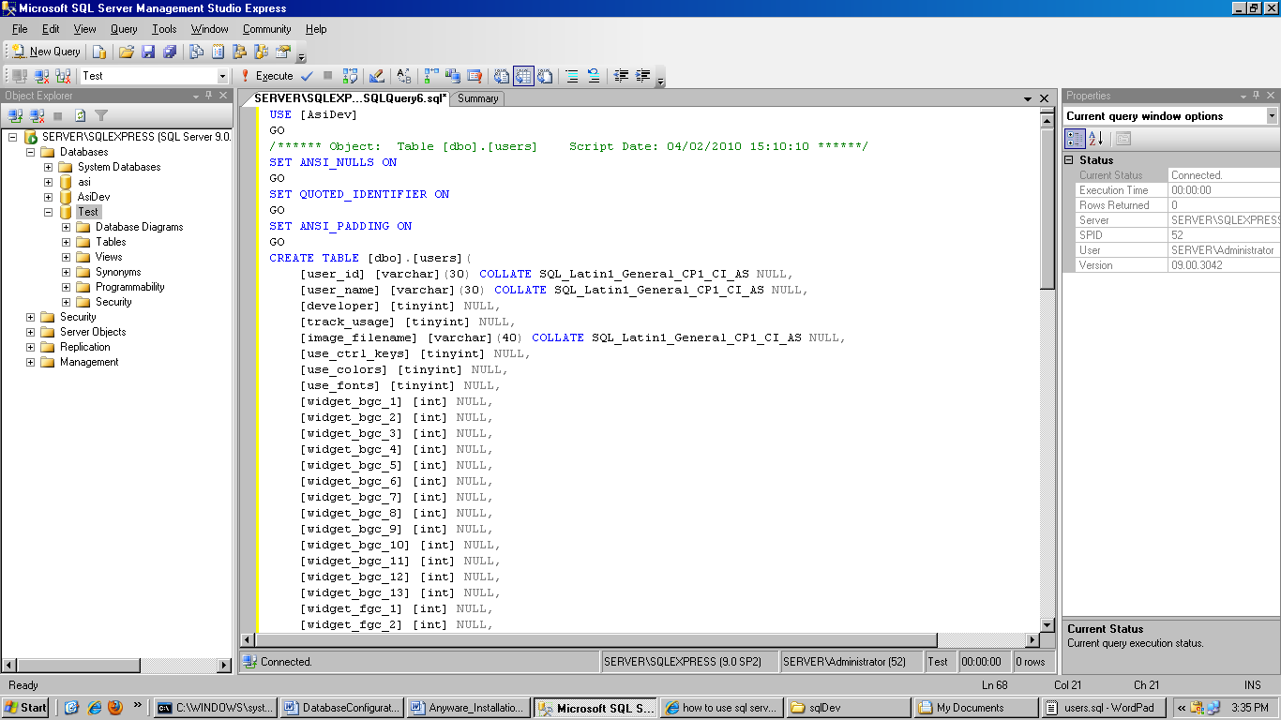

- Press F5 Button. Your table will be added & it will display the message Command(s) completed successfully as the screen displayed Below:

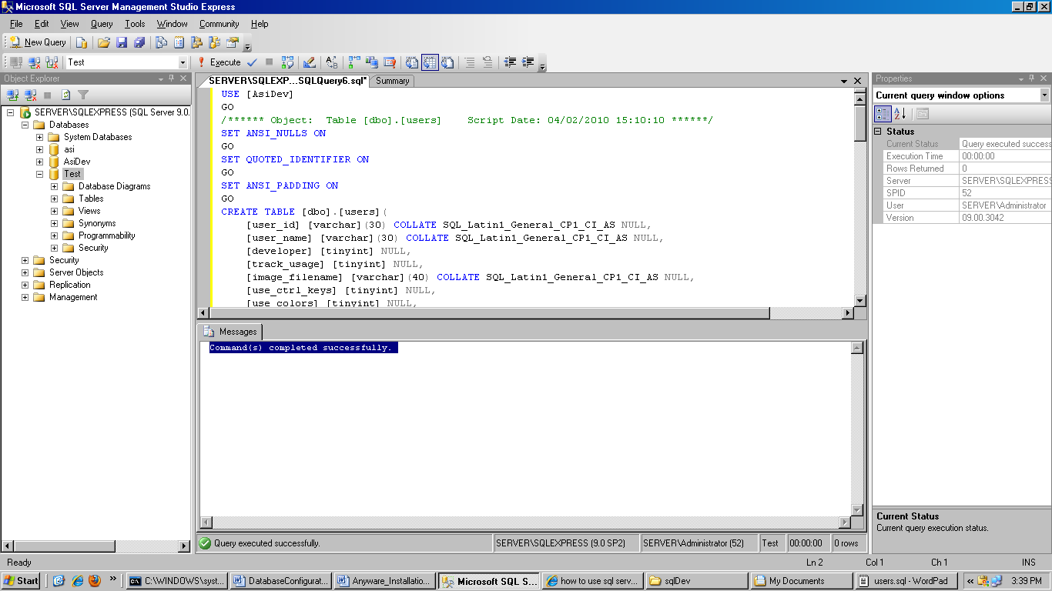

- Close the Query window.
- Right Click on Databases & choose Refresh option, you will find the table in the database as screen displayed Below:

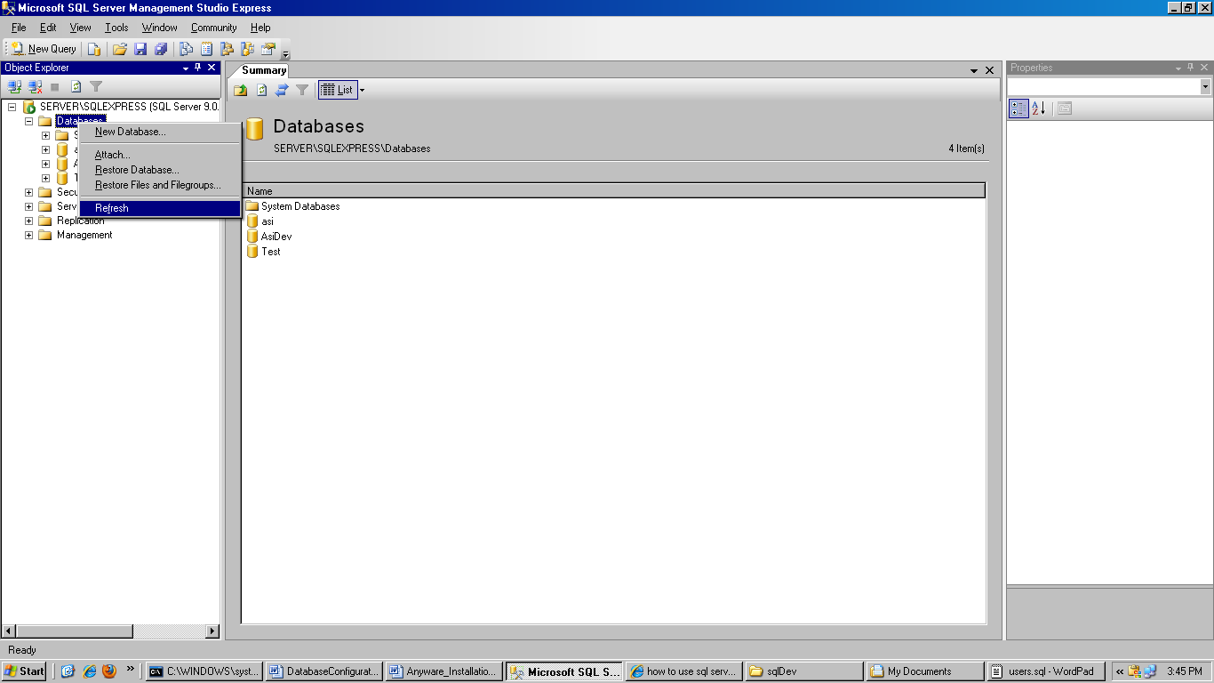

Add New Field to Database Table:

- Right Click on Database Table where you want to add new field. Choose option (Modify or Design) it depends on you SQL Server Management Studio.

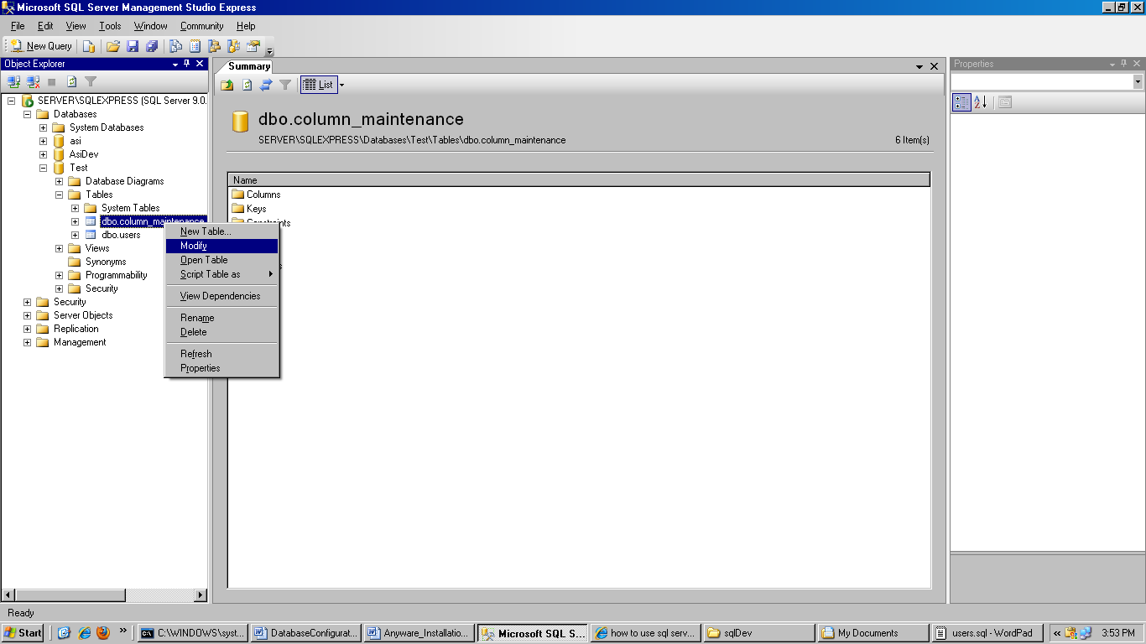

- Click where you have to add new column as screen shows Below:

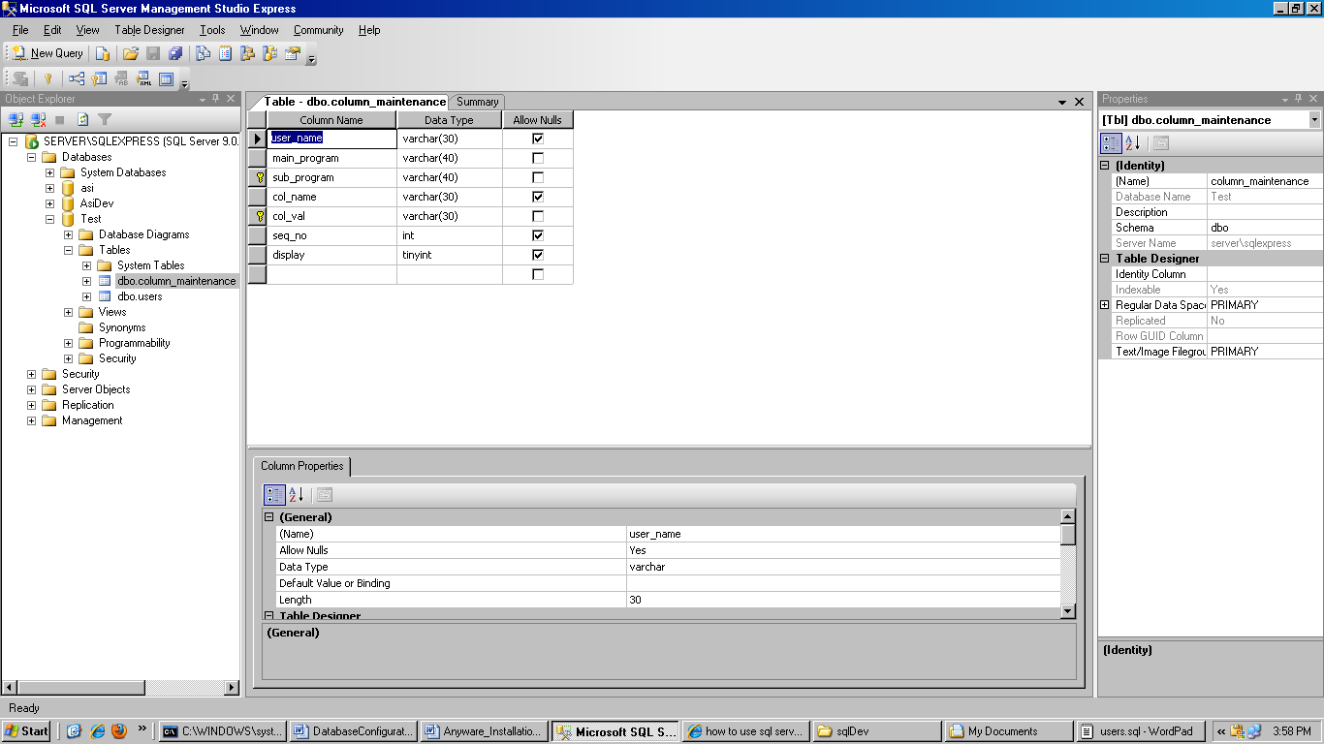
Click Here

- Enter New Column Name & its DataType as the screen displayed Below:

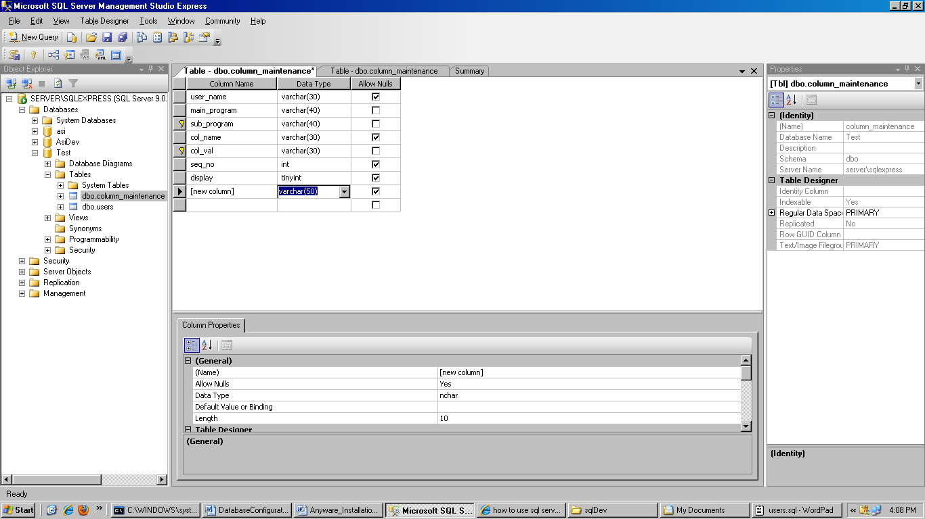

Choose File -> Save option as the screen displayed Below:

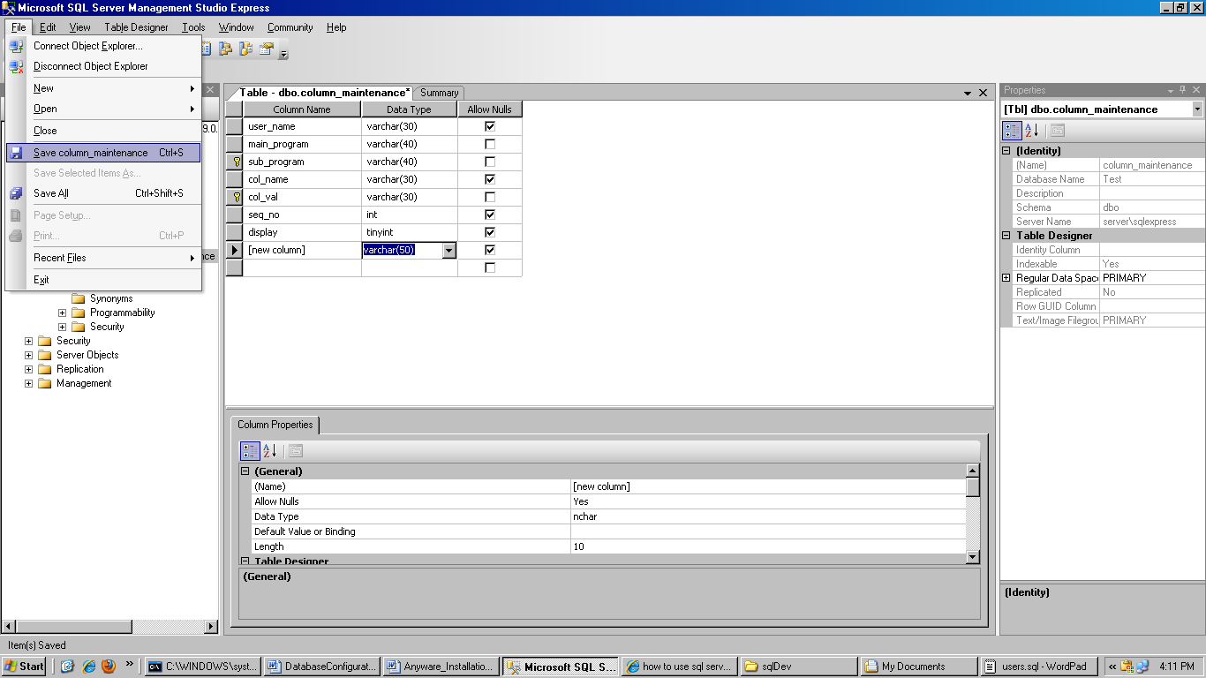

It will add a new field to database table.

